
SCHOOL OF COMPUTING AND ENGINEERING SCIENCES (SCES)
BACHELOR OF SCIENCE IN ELECTRICAL AND ELECTRONICS ENGINEERING (BSEEE)
BEE 3206: CONTROL SYSTEMS_1 Lab 2
GROUP 5
Report By:
Mwongela Edward Aribu
142092

LECTURER: PROF. MWANGI MBUTHIA
LABORATORY TECHNOLOGIST: MR. JAMLICK NTOJIRA
17th September 2023

Contents
List of figures 2
Title 2
Abstract 2
Introduction 3
Electric motor rating 3
(Weight) Mass 3
Aerodynamic Drag 3
Methods and Materials 3
Assumptions 3
Results 4
Discussion 5
Conclusion 5
References 5

List of figures
Figure 1 3

Title: All Electric Racing Car

Abstract
Objective
Estimate the electric motor rating, mass and aerodynamic drag coefficients for an electric racing car
Determine the lap time when the electric car is driven on a simplified racing track
Learning Outcome:
Understand how to use a mathematical model to represent the dynamics of an electric
Explain how the electric motor rating, mass and aerodynamic drag affect the car rated speed and acceleration.

Introduction

Electric motor rating
Power Output: A car's acceleration and top speed are directly influenced by the electric motor rating, which is commonly expressed in kW or HP. A more powerful motor will generate more torque and acceleration, allowing the vehicle to accelerate faster.
Torque: Electric motors instantly produce torque, which helps them accelerate quickly. More torque can be produced by motors with higher ratings, allowing for speedier acceleration from stopping position.
Efficiency: The electric motor's capacity to maintain high speeds can be impacted by its efficiency. More effective motors can operate at high speeds for extended periods of time while wasting less energy as heat.

(Weight) Mass
Inertia: A car's mass influences its ability to accelerate and decelerate. Heavier vehicles have greater inertia, requiring more force to accelerate and stop. As a result, acceleration will be slower and braking distances will be greater.
Momentum: Once an automobile is moving, its mass has an impact on its capacity to maintain speed. Heavier vehicles have more momentum, making it more difficult to change speed or direction. This can influence a vehicle's agility and reactivity at greater speeds.

Aerodynamic Drag
Aerodynamic drag is a force that resists the motion of the car as it passes through the air. The drag coefficient measures how aerodynamic the shape of a car is. Lower drag coefficients minimise the resistance the car faces, allowing it to travel faster while using less power.
Cross-Sectional Area: The frontal area of the car influences aerodynamic drag as well. Larger cross-sectional areas generate more air resistance, which limits top speed and may reduce acceleration.
Speed Restrictions: As an automobile speeds, aerodynamic drag increases. Overcoming air resistance at high speeds necessitates additional power. Cars with lower drag coefficients operate better at high speeds.

Methods and Materials

Assumptions
- An Electric Racing Car is driven around a flat racing track shown in figure 1.
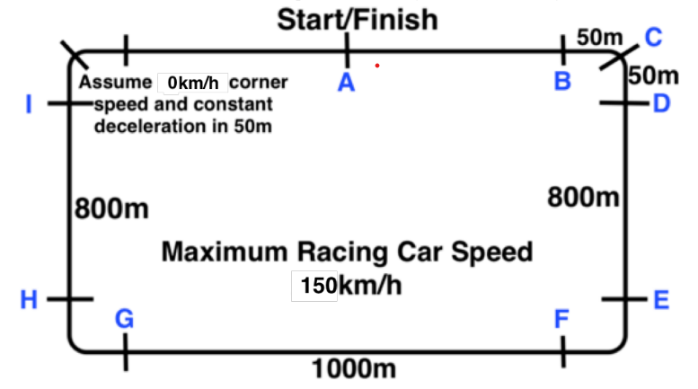
Figure 1
- The racing car is modelled as a simple Cart on wheels.
- Assume the Racing Car Longitudinal dynamics is modelled using the LDE where M is the lamped car mass, v is the car speed in m/s, b is the aerodynamic drag coefficient proportional to the speed and F is the force produced by the electric motor.
- Assume the power source is a battery bank enough to cover 160km before recharging

Use the following references provided in the shared drive to complete this Lab.
(a) Selection of Power Rating of an Electric Motor for Electric Vehicles
(b) Design of electrical powertrain for Chalmers Formula Student with focus on 4WD versus RWD and regenerative braking
(c) Development and Validation of a Single Mass Lap Simulation

Results
5.2 Estimate the electric motor rating, mass and drag coefficients for an electric
racing car
(i) Assuming the racing car driver has a maximum weight of 80Kg, calculate the motor rating
(KW) and the value of F to achieve a maximum speed of 150Km/h (Hint 1 Watt = 1Nm/s)
(ii) Explain how you can estimate values for the car superstructure masses consisting of drive system, batteries, wheels etc and calculate the value of M.
(iii) With the value of the mass calculated in (ii) above, calculate the value of b.
(iv) Using values of F, M and b obtained above, solve for v(t) and calculate 5 transient and 1 steady
state value of v(t). Plot your solution using MATLAB showing values of Motor Rating, F, M
and the 5 calculated values of v(t) on the graph.
5.3 Determine the lap time when the electric car is driven on a simplified racing track
(i) Using the parameters determined in 5.2, calculate the approximate time to make one 1 lap round
the track.
(ii) Explain how you can reduce the lap time.
(iii) With your new choice to improve the lap time, plot your v(t) using MATLAB showing values
of Motor Rating, F, M and b and calculate the lap time.
(iv) Calculate the new lap time.

Discussion
- When writing a discussion, try to answer these questions:
  - What do the results indicate?
  - What is the significance of the results?
  - Are there any gaps in knowledge?
  - Are there any new questions that have been raised?
- What objectives were achieved in your practical experiment?

Conclusion

References

